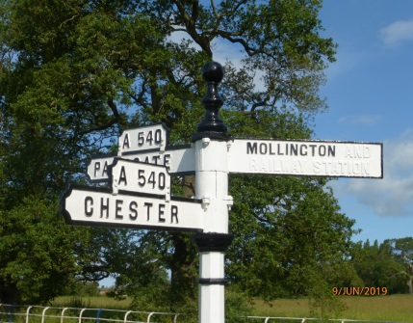 | 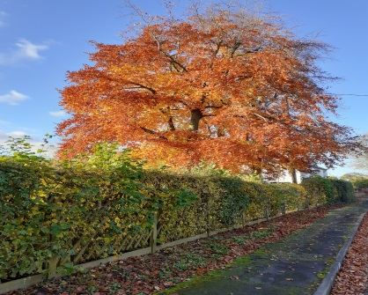 | 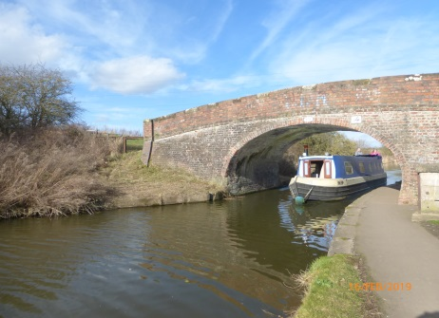
Your Parish Councillors: It is with sadness we note the death of Brian Crowe in January this year. Brian was Lord Mayor of the City of Chester (2002-3) and served on Mollington Parish Council for over 20 years. He will be sorely missed.
Cllr Angus MacSween has retired this year after serving many years on the Parish Council. Angus provided support with all manner of tasks maintaining and improving our village. We thank him for all his efforts over the years.
In September, Cllr Sally Atkin resigned following a family bereavement. Sally’s knowledge of local history and council procedures was invaluable. Sally was keen to carry out work on tree preservation and the Parish Council would be interested in hearing from residents who might be interested in helping the council to continue with this work.
Dave Wells joined the Parish Council in November 2020; Dr Mike Riley joined the Parish Council in March 2021.
Covid 19: The pandemic has caused significant changes to the operation of the council and we have been conducting our meetings using Zoom. This did take some getting used to but we are now much more Zoom literate. We do look forward to getting together face to face when possible but I am sure we will continue to use Zoom as a tool in our communications.
We, with other agencies, launched a program to assist elderly residents at the start of the lockdown, primarily with support for shopping, prescription collection and some maintenance activities.
Hyperfast Broadband: There continues to be a requirement for high speed broadband within the Parish as some properties are finding their internet capability is very poor. It is predicted this will be further exacerbated in the coming years. B4RN continues to be the front runner and 191 GIGABIT vouchers have now been applied for. Backford and Chorlton hope to start installation shortly. In Mollington, the Hyperfast team are now just 40 vouchers short of the milestone that will trigger the building process so now is a good time to sign up to the scheme.
Drainage and flooding issues: Storm Christoph caused significant damage and flooding throughout Cheshire. In Mollington and Lea, Grove Road was the most affected area with Parkgate Road also affected. Our thanks go to residents who have cleared ditches and drains to improve run off on Grove Road towards The Green and Demage Lane. We identified a collapsed drain and blockage in the drainage system on the southern end of Grove Road which Highways have now repaired. I am pleased to report we have had no further problems even with heavy rain over the last few weeks.
Mollington PC has appointed Dave Wells to act as a Flood/Drainage Champion liaising with residents in Mollington and Lea to ensure we have systems in place to reduce the effect of heavy rain in the future. Dave is preparing a questionnaire to identify further actions which will be circulated in the coming weeks.
Traffic Speed through the Village: As reported 12 months ago, working with Lea Parish Council we initiated a project to have a speed limit on Grove Road from the Riding Stables to the school. The project was delayed by the Covid situation but I am now pleased to report that letters seeking the views of residents along the road have been distributed and the responses received have been overwhelmingly positive. We have tried to have the speed reduced to 30mph but have repeatedly been informed by Highways that 40mph is the lowest speed they will accept. I anticipate this will be enacted over the next three months.
We are also looking at speed reductions as you turn into Townfield Lane from the Parkgate Road and along the Parkgate Road itself by Well Cottage.
House Number/Name project: Some residents particularly on Townfield Lane suggested it would be helpful to Emergency Services if we had house numbers in addition to house names on roads in the village. We are fortunate to have an expert in geo-location in the village and she was able to assure us that emergency services and the larger delivery companies can now locate a property with pinpoint accuracy using geo location tools such as WHAT 3 WORDS and the location tool on WHATSAPP. Clear, well maintained name plates prominently displayed outside properties also help.
Mollington Golf Course Development (The Green): In August 2020, a planning application was submitted to CW&C for permission to build six houses on the site of the old golf course. The Parish Council initiated a survey of all Mollington Residents to gauge reaction to the application. We received 60 responses mainly objecting to the proposed development. The primary objection was concern that this was the “thin end of the wedge” and further development would follow. I submitted a summary of your comments to the Council and our Ward Councillor Simon Eardley “called in” the application (ensuring greater scrutiny) in September. There has been no further action on this planning application since then. I will keep residents informed as further information comes to light.
General maintenance: We continue to work with CW&C to ensure our roads are maintained. There has been an elongation in response time from CW&C due, we are told, to Covid. Road repairs, gutter cleaning and drain clearances do appear to take place within a few weeks following reports. So please, if you notice potholes, damaged notices, malfunctioning lights, litter etc. use the CW&C portal to report these. It’s simple and the quickest way to get issues actioned.
Once again, I would like to thank those residents who have helped to maintain our village through cleaning signs, litter picking and general maintenance.
Village Hall: I am sure we are all pleased to see the building work has started and we look forward to using the new facility. The latest completion date we have is late summer this year. Your Parish Council along with Lea By Backford and Backford have taken out a Public Works Loan Board loan to help fund the project. Mollington’ s contribution is £30,775.00 to be paid back over 15 years.
Communication: In a joint project with Lea by Backford and Backford Parish Councils, Simon Eardley has helped to fund a community website: www.thefivevillages.org.uk and a community newsletter: ‘Are you in the Know?’ These are in their infancy but will become useful resources for residents and visitors to the villages. In another joint initiative all three parish councils jointly commissioned new websites. Mollington’ s website is www.Mollington-pc.org.uk
Finally, I would like to take this opportunity to thank residents and my fellow councillors who have volunteered their time and energy to make the village a better place over the last 12 months. It has been a difficult and strange year for all. Let’s hope that this year brings some relief from lockdown and we can again enjoy other peoples’ company once again.

Roger Jones
Chair Mollington Parish Council

